Social Fitnessing Challenge Marketing Plan

Week of June 1
- Post flyers announcing the challenge
- Add the flyer content to club newsletter
- Setup a dry erase scoreboard inside the entrance to the fitness center. Here’s a photo from a previous challenge we organized:

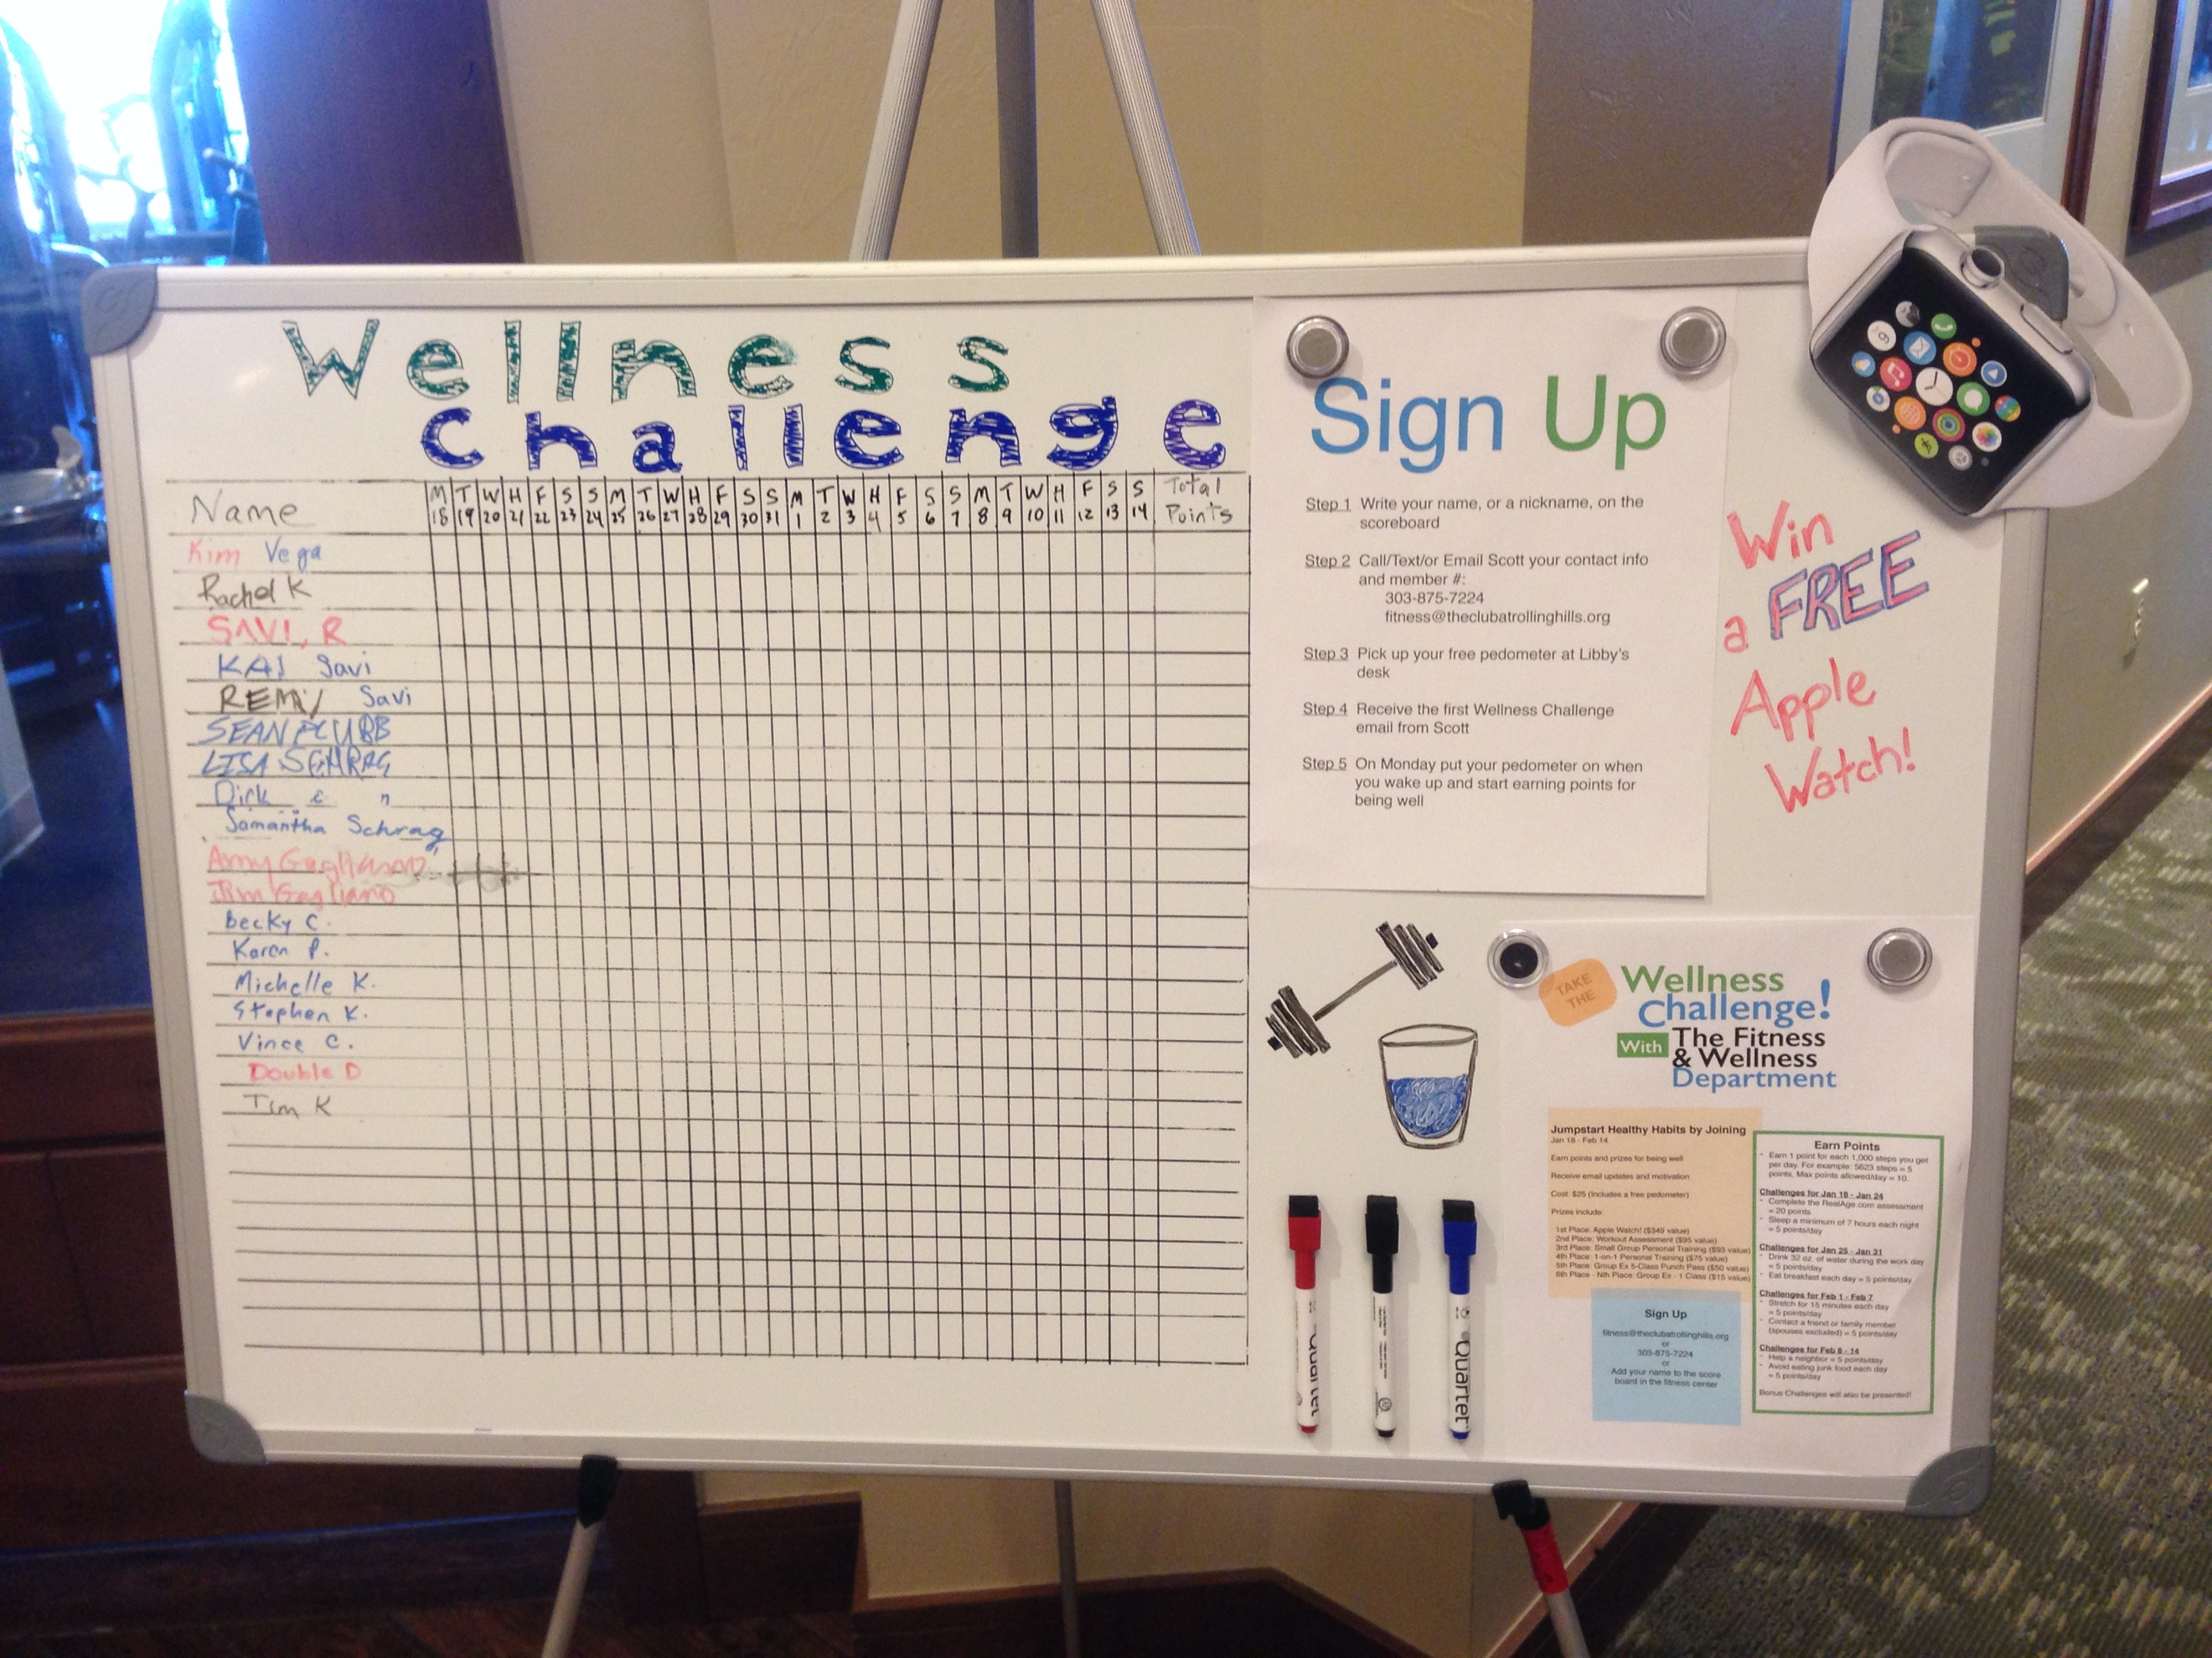

Week of June 8
- Ask/require each personal trainer to get 10 members to sign up
- Keep flyers and club newsletter info posted
- Post mini versions of the challenge flyers on cardio machines
- Update dry erase board with new participants

Week of June 15
- Update club newsletter
  - Join the Social Fitnessing Challenge to help (club name) compete against members of other private clubs across the country!
- Keep flyers, mini flyers, and club newsletter info posted
- Move the dry erase scoreboard to another area of the club (preferable one with high traffic)
- Update dry erase board with new participants
- Start an email chain with all challenge participants. Provide challenge rules, motivation, etc. Get some banter going!

Week of June 22
- Check in with personal trainers to make sure each are on track to get 10 members signed up
- Send an email to all members inviting them to join the Social Fitnessing Challenge
- Keep flyers, mini flyers, and club newsletter info posted
- Move the dry erase scoreboard to another area of the club (preferable one with high traffic)
- Update dry erase board with new participants
- Start an email chain with all challenge participants. Provide challenge rules, motivation, etc. Get some banter going!

Week of June 29
- Keep flyers, mini flyers, and club newsletter info posted
- Move the dry erase scoreboard to another area of the club (preferable one with high traffic)
- Update dry erase board with new participants
- Start an email chain with all challenge participants. Provide challenge rules, motivation, etc. Get some banter going!

